Assignment 5 Arduino Application

Released Date: Nov 13th

Version 1.0

Format: Name the document in the combination of name、ID and No. of Assignment.

**Example: Ping Yi_23_Assignment1.doc**

**Email the document to “pingy@wxit.edu.cn” before Nov 20th.**

**Task** Design a circuit using a temperature sensor, three LEDs indicate different levels of temperature stages, the detailed information will be displayed on LCD1602. Once the simulated temperature is over the 60 degrees Celsius, then the piezo will give an alarm to indicate overheating.

设计一个使用温度传感器的电路，三个led指示不同水平的温度级，详细信息将显示在LCD1602上。一旦模拟的温度结束 60摄氏度，然后压电会发出过热。

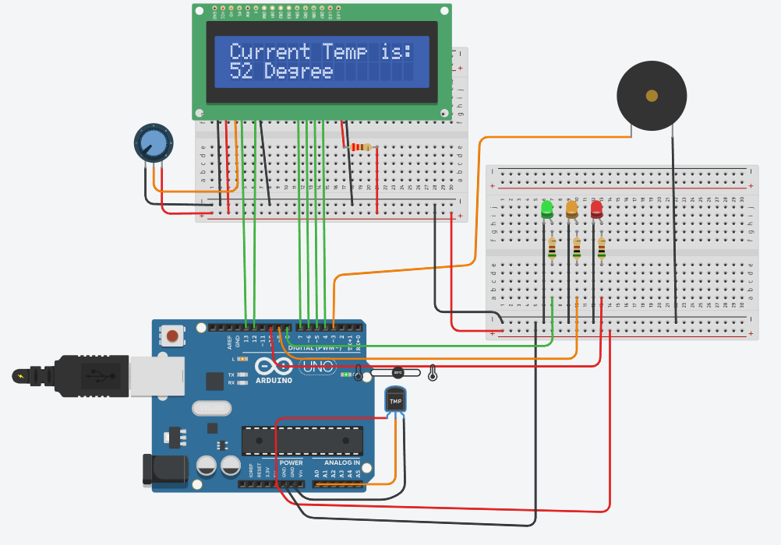

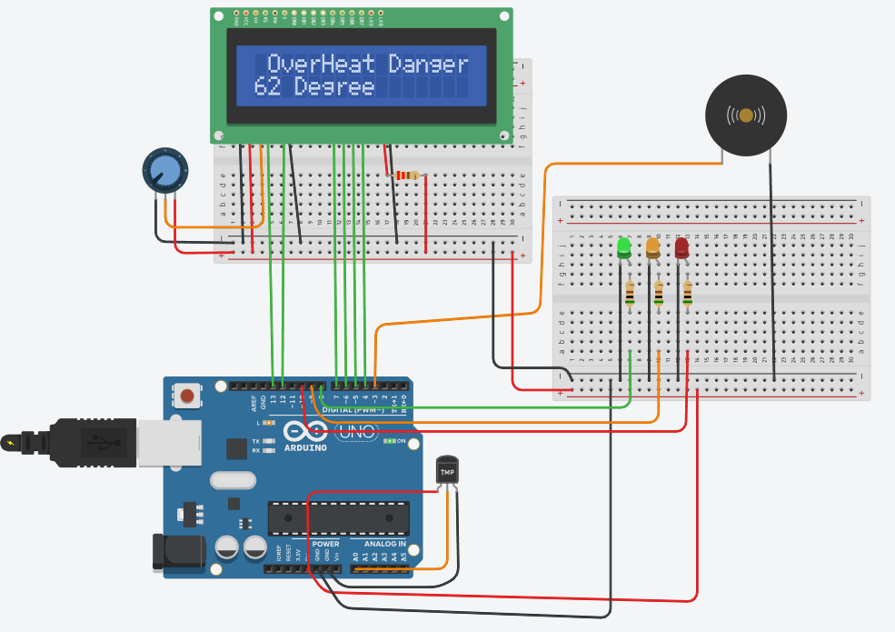

Figure 1 Application Structure and Requirement